

**Faculty of engineering - Shoubra**

**Benha University**

**Research Article / Research Project / Literature Review**

in fulfillment of the requirements of

|  |  |
| --- | --- |
| **Department** | **Engineering Mathematics and Physics** |
| **Division** | **----------** |
| **Academic Year** | **2019 - 2020 Preparatory** |
| **Course name** | **Computer** |
| **Course code** | **ECE001** |

**Title :-**

**Build a website on artificial intelligence**

**By :**

|  |  |  |  |
| --- | --- | --- | --- |
|  | Name | Edu mail | B.N |
| 1 | Mohamed Ali  Abd-Elrizek Mohamed Nowar | muhammed195858@feng.bu.edu.eg | 767 |

**Approved by :**

|  |  |
| --- | --- |
| Examiners committee | Signature |
| Dr. Ahmed Bayoumi |  |
| Dr. Shady Elmashad |  |
| Dr. Abdelhamid Attaby |  |

**Github Link :**

**Github Page (published website) :**

**Application Brief**

[Artificial Intelligence](https://www.simpliv.com/machinelearning/learn-artificial-intelligence-for-beginners?ref=hackernoon.com) uses intelligent machines built in a way that they react like humans. The primary process involved in making these smart machines is to carry out decision making, which analysis and uses data available in an enterprise. It is similar to the human mind absorbing and synthesizing information and providing with the required decision.

AI can be used extensively in the healthcare industry. It is applicable in automated operations, predictive diagnostics, preventive interventions, precision surgery, and a host of other clinical operations. Some individuals predict that AI will completely [reshape the healthcare landscape](https://readwrite.com/2019/08/29/3-ways-video-technology-can-improve-patient-safety-in-healthcare/) for the better.

Using the combination of Artificial Intelligence, Machine learning and deep learning is going to be very useful because they are adding a lot of value to the current process and also providing a thoughtful path for the individuals to move forward.

Artificial intelligence is very useful in all industries as more research is being done to advance it. The advancements in this AI tech will be most useful if it is understood and trusted. An important part of it is that artificial intelligence and related technologies such as drones, robots, and autonomous vehicles can create around [tens of millions of jobs](https://readwrite.com/2019/08/27/why-now-is-the-time-for-marketers-to-embrace-ai/) over the next decade.

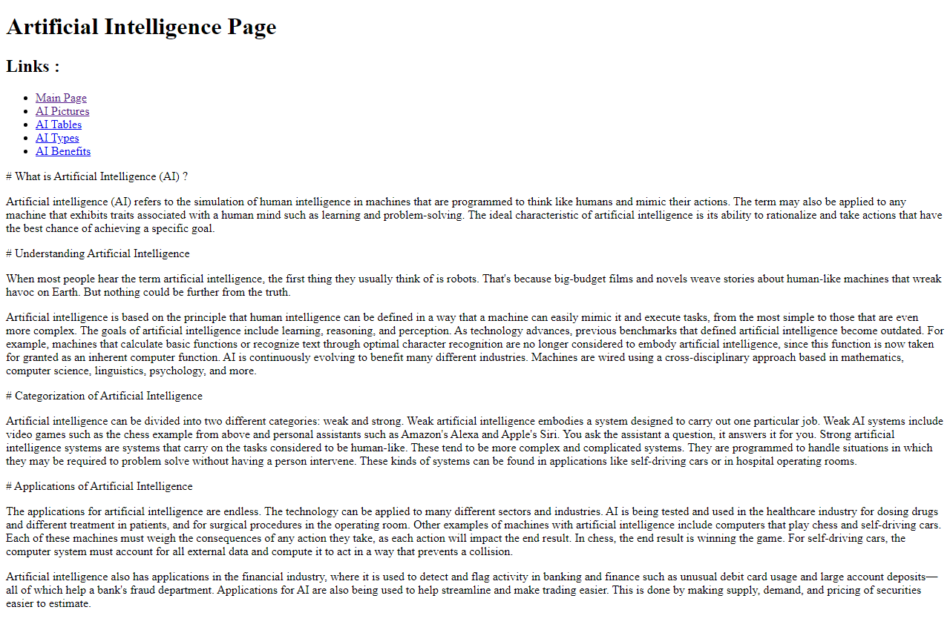**Screenshots**

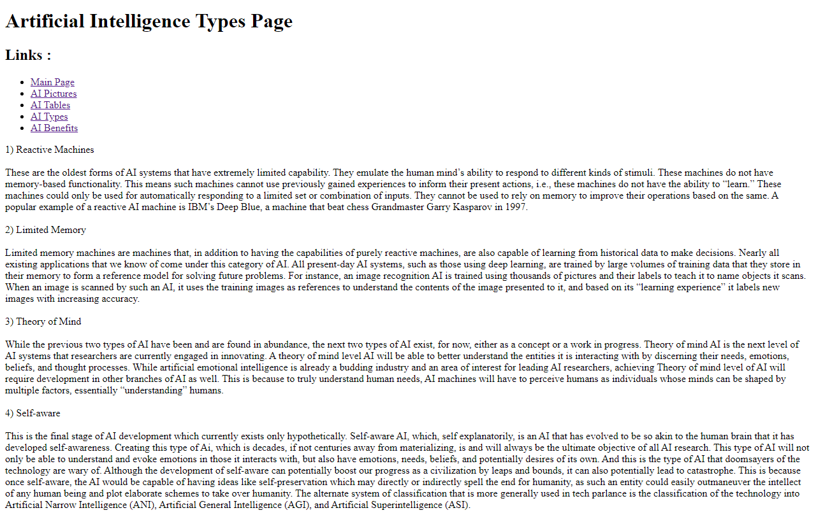

**Source Code**

